**Surface Finishing with Magneto-Rheology based Machining Process**

### A PROJECT REPORT

***Submitted by***

|  |  |
| --- | --- |
| **ABIJITH GOPAL R** | **(211419114003)** |
| **ARUN KUMAR K S** | **(211419114039)** |
| **BALAJI S** | **(211419114050)** |
| **BHARATH B** | **(211419114053)** |

***In partial fulfillment for the award of the Degree***

***Of***

## BACHELOR OF ENGINEERING

**IN**

## MECHANICAL ENGINEERING



**PANIMALAR ENGINEERING COLLEGE**

**(An Autonomous Institution, Affiliated to Anna University, Chennai)**

**APRIL 2023**

**PANIMALAR ENGINEERING COLLEGE**

**(An Autonomous Institution, Affiliated to Anna University, Chennai)**

## BONAFIDE CERTIFICATE

Certified that this project report **“Surface Finishing with Magneto-Rheology based Machining Process”** is the bonafide work of

|  |  |
| --- | --- |
| **ABIJITH GOPAL R** | **(211419114003)** |
| **ARUN KUMAR K S** | **(211419114039)** |
| **BALAJI S** | **(211419114050)** |
| **BHARATH B** | **(211419114053)** |

who carried out the project work under my supervision.

**SIGNATURE SIGNATURE**

**Dr. L. KARTHIKEYAN M.E, M.B.A, Ph.D. Mr. I.JOHN SOLOMON M.E. PROFESSOR & HEAD Asst. PROFESSOR**

Dept. of Mechanical Engineering Dept. of Mechanical Engineering, Panimalar Engineering College Panimalar Engineering College,

Bangalore trunk road, Bangalore trunk road, Varadharajapuram,Nasarathpettai Varadharajapuram,Nasarathpettai, Poonamalle,Chennai-600123 Poonamalle,Chennai-600123

Submitted for viva –voce examination held on during the

Year…………. at Panimalar Engineering College, Chennai-600 123

### 

### INTERNAL EXAMINER EXTERNAL EXAMINER

ii

# ACKNOWLEDGEMENT

At the outset we would like to express our gratitude to our beloved respected **Chairman, Dr.Jeppiaar,** Our beloved correspondent and Secretary **Mr.P.Chinnadurai M.A., M.Phil., Ph.D.,** and our esteemed director for their support.

We would like to express thanks to our Principal, **Dr. K. Mani M.E., Ph.D.,** for having extended his guidance and cooperation.

We would also like to thank our **Head of the Department**, **Dr.L.Karthikeyan M.E., Ph.D., professor, Department of Mechanical Engineering** for his encouragement.

Personally, we thank **Mr. I.JOHN SOLOMON M.E. Asst. Professor in Department of Mechanical Engineering** for the persistent motivation and support for this project, who always was the mentor of germination of the project from a small idea.

We express our thanks to the project coordinator **Mr. J.GUNASEKARAN M.E., Ph.D.,** **Asst professor and J.SRINIVAS M.E., Asst professor in Department of Mechanical Engineering** for the Valuable suggestions from time to time at every stage of our project.

Finally, we would like to take this opportunity to thank our family members, friends, well-wishers who have helped us for the successful completion of our project.

We also take the opportunity to thanks all faculty and non-teaching staff members to our department for their timely guidance to complete our project.

iii

**ABSTRACT**

Surface Finish is most important property in machining process. Due to poor surface finish, we have poor quality product. The quality plays a vital role in every product. In traditional machining process we cannot get cost effective finishing. Hence, we developed a machining process to improve surface finish during operation. Magneto-rheological Fluid sponsored such kind of high-quality surface finish. Magneto rheological (MR) fluid is a smart fluid whose flow behaviour can be altered with the application of magnetic field. The MRF technology has ability to transmit shear force in a controllable manner by application of magnetic field.

The project represents surface finishing operation by using MR fluid. The surface finish operation carried out on Aluminium (6061) material by using three different compositions of MR fluid as well as at three different speeds. To achieve different speeds, drilling machine is used and initial and final surface roughness values of the work piece at each speed is observed and calibrated by surface roughness tester (Ra value). Different samples are created with three different composition of silicon carbide with iron carbide and de-ionized water.

The main objective of the project motivates Surface finish at high quality by achieving Tolerance Limits when compared to other conventional machining methods like cylindrical grinding, centerless grinding, etc. Aluminium material is selected because in conventional machining process it is not possible to obtain surface roughness beyond certain microns and in other hand process, carried out by CNC will gradually increases the Machining cost and labour cost. To eliminate the above demerits in Surface finish of Aluminium and achieve high quality of surface finish, smart fluid called MR fluid is to be used.

iv

# TABLE OF CONTENT

### Chapter No.

**Title Page**

**No.**

1. Abstract iv
2. List of Figures vi
3. List of Tables vii
   1. Introduction 1
      1. Problem Identification 2
   2. Literature Review 4
      1. History of MR Finishing 4
      2. Friction Behaviour of MR Fluids With   
         Different Materials 5
      3. Effects Of Magnetic Field ,Strength In   
         Different Type of MR Fluids 5
      4. Optimization of Machining Parameters   
         During CNC 6
   3. Methodology 8
   4. MR Fluid Material 9
      1. Carbonyl Iron Powder 9
      2. Carbonyl iron powder Specifications 9
      3. Uses 10
      4. Silicon Carbide Powder 11
      5. De-Ionized Water 12
      6. Difference Between distilled water  
         and De-ionized Water 13
      7. Preparation of Distilled Water 13

v

* + 1. Preparation of De-Ionized Water 13
    2. Lithium Grease 14
    3. Permanent Magnet 14
  1. Workpiece Material 17
  2. Fabrication 19
  3. Pre-Finish of Al 6061 20
  4. Preparation Of MR Fluid 21
  5. Design Of Workpiece 22
  6. Experimental Method 24

10.1 Preparation of Sample 24

10.2 Available Speed 25

10.3 Selection of Speed 25

* 1. Experimental Setup 26

11.1 Experimental Setup 26

11.2 Surface Roughness Tester 27

11.3 Procedure for Measuring   
 Surface Roughness 28

11.4 Parameters in Surface Roughness 29

11.4.1 Mean Roughness(Ra) 29

11.4.2 Root Mean Square Deviation 29

11.4.3 Average Maximum height   
 of the profile 29

11.4.4 Unit Conversion of Surface  
 Roughness 29

vi

* 1. Result And Discussion 30
     1. Tabulation 31
     2. Percentage Decrease in surface   
        Roughness 32
  2. Cost Estimation 36
  3. Scope Of Future Project 37
  4. Conclusion 38
  5. References 39

vii

|  |  |  |
| --- | --- | --- |
|  | **LIST OF FIGURES** |  |
| **FIGURE NO** | **TITLE** | **PAGE NO** |
| 3.1 | Process flowchart | 8 |
| 4.1 | Carbonyl Iron Powder | 9 |
| 4.2 | Silicon Carbide Powder | 12 |
| 4.3 | Permanent Magnet | 15 |
| 5.1 | Aluminium 6061 Plate | 17 |
| 6.1 | Pre finish of Al 6061 | 20 |
| 9.1 | 3D Model of Tool | 22 |
| 9.2 | Fabricated Tool | 22 |
| 9.3 | Detailed View of Tool | 23 |
| 11.1 | 2D Diagram of Experimental Setup | 26 |
| 11.2 | Experimental Setup | 26 |
| 11.3 | Surface Roughness Tester | 27 |
| 11.4 | ISO Symbols of Ra | 29 |

# viii

|  |  |  |
| --- | --- | --- |
|  | **LIST OF TABLES** |  |
| **TABLE NO** | **TITLE** | **PAGE NO** |
| 4.1 | Composition of Carbonyl Fe Powder | 10 |
| 10.1 | Composition of SiC | 24 |
| 10.2 | Selection of Speed | 25 |
| 12.1 | Values of Ra at 600 rpm | 31 |
| 12.2 | Values of Ra at 1100 rpm | 31 |
| 12.3 | Values of Ra at 1750 rpm | 32 |
| 12.4 | Characterization of Ra at 5% SiC | 32 |
| 12.5 | Characterization of Ra at 10% SiC | 33 |
| 12.6 | Characterization of Ra at 15% SiC | 34 |
| 12.7 | Percentage Decrease in Ra | 35 |
| 13.1 | Cost Estimation | 36 |

**ix**

**CHAPTER 1**

**INTRODUCTION**

Magneto-rheological fluid (MRF) is a type of smart material in which its properties will be changes when the magnetic field imposed on the fluid. In its initial stage i.e., during the absence of magnetic field, MR Fluid acts as a purely in liquid state and during the presence of magnetic field, the fluid increases its viscosity until to the state of viscoelastic (Property that exhibits both viscous and elastic characteristics) solid.

When the MR Fluid is in viscoelastic state, the molecules present in the fluid get aligned in a straight line and molecules attracts closer. Due to this, Shear rate of the fluid gets stronger. At this time, the work piece will be immersed into the fluid which is under viscoelastic state and tends to give rotary motion that strikes the MR fluid. Since both MR Fluid and Work piece undergoes shearing restrictions, Friction will be created, and the material removal takes place.

In this project, the prediction of surface roughness parameters of an Aluminium 6061 plate was studied. In this study, Magneto-rheological finishing is used to obtain precise controllable finishing forces without any external damages. Here MR Fluid plays a super finishing medium which is the combination of Carbonyl iron powder (magnetic medium), silicon carbide(abrasive particles) and De-Ionized water.

The preparation of MR Fluid is taken at various composition levels such as 5, 10 and 15% Silicon Carbide concentrations for the same Carbonyl iron powder concentration. The various Silicon Carbide concentration was prepared in a separate beaker respectively. The Surface roughness of Al6061 for different compositions was studied individually. Here different work piece is used for the different compositions and filed separately for the identification of the work piece.

**1**

The rotary/stirring motion is achieved in this project by drilling Machine. For this motion setup, design of a new tool was made in which one end of tool cylindrical tapered and in circular cross section which is inserted and fixed with collet of the machine and the other end of the tool is designed like fork having two teeth at required gap for the project. The tooth having align screw to fix the work piece firmly.

The drilling machine has speed variation depending on the pulley setup. In this project, the surface roughness is measured for the different speed ranges of all the individual work piece. The behaviour of the MR Fluid and the work piece is observed from the initial to the maximum speed ranges.

Hence, In this MR Fluid based machining process, the parameters are analyzed by varying composition of material and also by varying angular speed of work piece.

* 1. **Problem Identification**

As in conventional machining process, which uses heavy machineries to perform machining operation and will not provide surface finish beyond certain point Moreover this operation is time consuming which requires skilled labour to perform the operation. Also the working environment becomes untidy due the chip disposal. This also includes the surface roughness influenced by various parameters such as feed rate, cutting speed, depth of cut, type of cutting tool. Since many industrial requirements are expecting good surface finish that cannot be satisfied by conventional methods and to provide good surface finish an alternative method called MR fluid is implemented.

On other hand, the work piece carried out is subjected to shear stress which affects the work piece directly whereas in MR fluid-based machining the work piece is not affected by any form of external stresses.

2

The conventional machining process requires cooling agent and lubricant to avoid heat, but MR fluid-based machining. process does not require any coolant because the fluid itself acts as a cooling agent and eliminates heat.

There are other means to obtain finer finish such as jet-based machining process but the major drawback it is quite expensive compared to other machining operations. MR fluid-based machining process is cheaper way to obtain fine surface finish.

3

**CHAPTER 2**

**LITERATURE REVIEW**

**2.1 History of Magneto rheological Finishing:**

Magneto rheological finishing (MRF) is deterministic method for producing complex optics with accuracy less than 50nm and surface roughness less than 1nm. MRF was invented at the Luikov Institute of Heat and Mass Transfer in Minsk, Belarus in the late 1980s by a team led by William Kordonski.

Inventor of MRF, William started work on magneto rheological (MR) fluids, which are suspensions of micron-size ferromagnetic particles, such as iron, in fluids such as oil or water. The viscosity of the fluid increases in the presence of a magnetic field. The stronger the field, the stiffer the fluid becomes. The increase in viscosity in the presence of a magnetic field called the magneto-viscous effect.

Initial interest was in using MR Fluids for mechanical applications such as vibrational damping and actuators. The main challenge was to create stable MR Fluid suspensions, rather than thick paste like mixture of solids and liquids. To measure the mechanical properties of MR Fluid, William Kordonski and their co researchers built the first magneto rheometer.

William’s group had an operating magneto rheological finishing (MRF) machine in Minsk. The first experiment by MR Fluid is done to obtain aspheric surfaces for optical glasses were made. A work piece such as ground glass lens is held on a rotating spindle. The spindle holding the work piece spins at 700 rpm and can be tipped from vertical to 25º off vertical. MR Fluid stiffens by a factor of 100 when it enters the 4-kilogauss magnetic field near the work piece. The stiffened fluid conforms to the shape of the work .   
  
 4

**2.2 Friction Behaviour of MR Fluid with Different Materials:**

The objective of this paper is to evaluate the friction and wear characteristics of MR Fluid in working condition with respect to the strength of the magnetic field for the different types of materials.

The surface of the specimen was cleaned by an ultrasonic cleaner with acetone. To understand the impact of variation of the friction coefficient, a low oscillation frequency and small load were set for the experimental conditions. In the test, the effect of magnetic field strength on the friction and wear characteristics is examined for different materials. Although the tester can apply a magnetic field strength of upto 25mT, only 9mT is applied for the test, because MR Fluid is completely converted into a semi solid from liquid state when magnetic strength is over 9mT. The friction characteristics of MR Fluid with boundary friction converted to dry friction on the contact surface are beyond the scope of the study.

**2.3 Effect of various magnetic field strength in different type of MR Fluids:**

Each type of MR Fluid has different properties of viscosity, density, solid content by Wright, and particle weight ratio, which are related to the friction characteristics. The Experimental condition for the test is as shown in the following table.

To observe the impact of the friction coefficient under different magnetic field strengths, the friction characteristics of MR Fluids and wear were studied under magnetic fields of 3, 6 and 9mT. The friction coefficient of 122EG, 132DG and 140CG increase with increasing magnetic field strength. Carbonyl Iron particles are constrained in a chain of magnetic particles under the magnetic field, but a few particles have an abrasive influence on friction process.

5

Magnetic particles turned into other friction pairs and direct friction occurred between the particles and materials, resulting in an increase in the overall coefficient of friction.

In this paper, friction characteristics of MR Fluids are evaluated with different types of MR Fluid, Material, and strength of the magnetic field.

* Iron particles in MR Fluid are arranged in the form of chains along the direction of a magnetic field resulting in the change of rheological properties of MR Fluid. It leads to higher friction coefficient at the contact surface.
* Three different materials such as aluminium, steel and brass are used for experiments as they are the most common material in mechanical applications. The experiments of friction characteristics are carried out with or without a magnetic field.
* The results show that the friction coefficient increases when a magnetic field is applied regardless of material. It is assumed that iron particles in MR Fluid get arranged in the direction of a magnetic field.

**2.4 Optimization of machining Parameters during CNC turning** **of**

**Al6061:**

In the modern manufacturing industry surface finish of the product is most important with high material removal rate (MRR). To get high surface finish various process are done on the product such as grinding, buffing and polishing. But these processes are very costly and time consuming. To reduce this manufacturing time and cost we are trying to get maximum surface finish by only turning process. Because turning is the first most machining operation to get finished surface. Automated and flexible manufacturing methods are used in the industries. CNC machines are used because they can achieve repeatedly and high accuracy.

6

There are many factors that affect the surface roughness of the product for example cutting speed, feed rate, depth of cut, coolant used, tool geometry, chattering, material properties of the work piece and cutting tool used Experiments are performed using high speed CNC turning machine. Turning operation is performed on rod of aluminium 6061 alloy.

After the experimentation, surface roughness is checked of both the turned and faced on the Taylor/Hobson contact type profilometer having the stylus radius having 2µm.

In this paper Response Surface Methodology was used to see the influence of the input parameters on the surface roughness of Al 6061 alloy.

* Feed rate is the main significant factor for surface roughness.
* Depth of cut and cutting speed has no significant effect on surface roughness.
* Contour and Surface plots was used for determining the optimal conditions to obtain required surface roughness.

7

**CHAPTER 3**

**Methodology**

**Figure 3.1 Process Flow chart**

i) 5% Sic

ii) 10% Sic

iii) 15% Sic

i) 30 mins

ii) 60 mins

iii) 90 mins

i) 600 rpm

ii) 1100 rpm

iii) 1750 rpm

Composition

Time

Speed

Parameters

Fixture

Experimental setup

Results and Discussion

Comparisons

Final Ra

MR fluid assisted machining.

Initial Ra

MR Fluids

Component Preparation

Fluid Preparation

Solution

Problem Identification

Carbonyl iron powder

Silicon Carbide

De-Ionized water

**8**

**CHAPTER 4**

**MR FLUID MATERIALS**

**4.1 Carbonyl iron powder:**

Carbonyl iron powder is formed from several other iron particles. The particle sizes vary anywhere from 20-200µm. The iron properties differ depending on the production method and history of a specific Carbonyl iron powder. There are three types of Carbonyl iron powder classifications: reduced Carbonyl iron powder, atomized powder, and electrolyte Carbonyl iron powder. Each type is used in various applications depending on their properties.

For the preparation of MR Fluid, micro sized powder of Iron (250-500 mesh) with the average size of 20µm is used. The Chemical Property of this Carbonyl iron powder is it contains 99% to 99.95% of iron and other sub particles at small quantity. Its Physical properties are almost all sizes and shapes along with powder granulation down to Nano particles. This type of Carbonyl iron powder is best suited for ferromagnetism-based projects. The specifications of used Carbonyl iron powder are as shown in the table.

Carbonyl iron powder is used in powder metallurgy of iron, steel and in combination with other metals. They are used in great quantities in the automotive industries as well as in ferromagnetism.

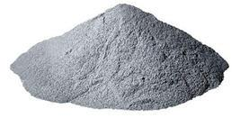

**Figure 4.1**

**Carbonyl iron powder**

9

**Table 4.1 Carbonyl iron powder composition**

|  |  |
| --- | --- |
| **Elements** | **Composition** |
|  | **(%)** |
|  |  |
| Assay | 99.5 |
|  |  |
| Lead (Pb) | 0.002 |
|  |  |
| Insoluble matter in HCl | 0.05 |
|  |  |
| Arsenic (As) | 0.0005 |
|  |  |
| Copper (Cu) | 0.005 |
|  |  |
| Manganese (Mn) | 0.05 |
|  |  |
| Sulphide (S) | 0.02 |
|  |  |
| Nickel (Ni) | 0.05 |
|  |  |

Pig iron is an alloy containing about 3% carbon with varying amounts of S, Si, Mn, and P. It is hard, brittle, fairly fusible, and is used to produce other alloys, including steel wrought iron contains a few tenths of a percent of carbon, is tough, malleable, less fusible, and has usually a "fibrous" structure carbon steel is an alloy of iron with carbon, with small amounts of Mn, S, P, and Si alloy steels are carbon steels with other additives such as nickel, chromium, vanadium, etc iron is the cheapest and most abundant, useful, and important of all metals.

**4.2 Carbonyl iron powder Specifications:**

CIPMS is a high purity Carbonyl iron powder with microsphere particles. CIPMS Carbonyl iron powder is an exceptionally fine and pure powder with unique characteristics such as:

* Spherical particles of less than 10 micrometers with defined size distribution
* Excellent compacting and sintering properties

10

* Unique electromagnetic properties
* Outstanding microwave and radar absorption
* Very high-quality consistency from batch to batch
* High chemical purity

**4.3 Uses**

It is used in the cores of high frequency coils that regulate the voltage in Smartphone, tablet PC, notebook, and other sensitive digital electronic devices.

**4.4 Silicon Carbide**:

There are many abrasive particles for the purpose of material removal. In this project, Silicon Carbide (500 mesh) with the size 25µm is used. Silicon Carbide is used to enhance the viscoelastic performances in the MR Fluid. Silicon Carbide achieves following properties for the requirement of abrasive fluid applications.

* High thermal conductivity
* High Hardness
* Superior corrosion resistance
* Good Mechanical Strength
* Wide ranging compatibility with other materials (Carbonyl iron powder)

Silicon Carbide (SiC) is a compound of silicon and carbon. It is extremely rare on the earth in mineral form, and it has semiconductor properties. It is also known as carborundum. It has a bluish-black appearance. It has many crystalline forms. It has a high sublimation temperature and is good heat conductor.

11

It’s expansion with increase in temperature is low. Also, it has high electric field breakdown strength.

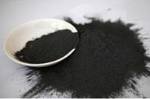

**Figure 4.2  
Abrasive Black Silicon Carbide Powder**

Based on the products, silicon carbide is segmented into types such as black, green, coated, refractory, metallurgical briquettes, metallurgical, and micro grit. Among all green and black are the major product segments and are anticipated to experience stagnant growth on near future. Demand for black silicon carbide is likely to boost over the forecast period on account of its increasing usage in ceramic, refractory and steel industries.

Applications of Silicon Carbide:

* Automobile Parts
* Foundry Crucibles
* Electric Systems
* Electronic Circuit System
* Power Electronic Device

**4.5 De-Ionized Water**

In this project, De-Ionized water at a pH level of about 5-8 is used. De-Ionised water is specially purified water which eliminates most of the minerals and salt ions such as Calcium, Magnesium, Sodium, Chloride, Sulphide, Nitrate and Bicarbonate.

12

De-Ionized water is generally considered distinct from distilled water.

Several stages of De-mineralization occur to obtain the required quality of the final product and some of these stages may also include reverse osmosis (RO) systems, where water is pressurized and forced through semi-permeable membranes which retain the mineral ions and other impurities as well as distillation and filtration.

**4.6 Difference Between Distilled and De ionized Water**

Distillation and deionization are similar in that both processes remove ionic impurities, but distilled water and deionized water (DI) are not the same and are not interchangeable for many lab purposes.

**4.7 Preparation of Distilled Water:**

Distilled water is a type of demineralized water that is purified using distillation. The source water for distillation could be tap water, usually the water is boiled, and the steam is collected and condensed to yield distilled water. Most minerals and certain other impurities are left behind, but the purity of the source water is important because some impurities will vaporize along with the water. Distillation removes salts and particulates.

**4.8 Preparation of Deionized Water:**

Deionized water is made by running tap water or distilled water through an electrically charged resin. Usually, a mixed ion exchange bed with both positive and negative charged resins is used. Cations and anions in the water exchange with H+ and OH- in the resins, producing H2O.

Deionized water is reactive, so its properties start to change as soon as it exposed to air. Deionized water has a pH of 7 when it delivered, but as soon as it encounters carbon dioxide from the air, the dissolved CO2 reacts to produce H+ and HCO3-, driving the pH closer to 5.6.

13

**4.9 Lithium Grease:**

Due to the weight and density of Carbonyl iron powder and silicon carbide, they sediment at the bottom of the container/beaker. To reduce the sedimentation, Lithium Grease is added as stabilizers. Sedimentation is measured by simple observation of changes in boundary position in clear part of MR Fluid placed into a transparent plastic beaker. Lithium Grease acts as carrier fluid as well as thickening agent. By adding desirable grease composition gives better effective amount of adhesive which is to provide a composition of consistency in the MR Fluid during the operation.

Lithum grease is being used as oil, thickener, and additives. The oil is the main dynamic lubricator, the thickener determines the physical characteristics of the product, and additives enhance the operating properties of the grease.

Lithium is a type of thickener, so not only provides structure to hold the MR Fluid in place, but it also acts as a sponge by releasing small amounts of oil during operation.

Benefits of Lithium Grease:

* Great long-term lubrication
* High Viscosity.
* Reduces friction and wear.
* Perfect for metal-to-metal applications.

**4.10 Permanent Magnet:**

Magneto-Rheological Fluid, this itself says that the fluid depends upon the magnetic field, and it is also called as Magnetic assisted Fluid. In this project Magnet plays a vital role to the fluid. Permanent Magnet is used in this project. The way the domain is oriented in a ferromagnetic substance depends on its property of magnetism.

14

The main advantage of a permanent magnet over any other type is that it does not requires continuous supply of external energy (in the case of electromagnets, electricity) to exhibit magnetism.

A permanent magnet is an object made from a material that is [magnetized](https://en.wikipedia.org/wiki/Magnetize) and creates its own persistent magnetic field. An everyday example is a [refrigerator](https://en.wikipedia.org/wiki/Refrigerator_magnet) [magnet](https://en.wikipedia.org/wiki/Refrigerator_magnet) used to hold notes on a refrigerator door. Materials that can be magnetized,

which are also the ones that are strongly attracted to a magnet, are called [ferromagnetic](https://en.wikipedia.org/wiki/Ferromagnetism) (or [ferrimagnetic.](https://en.wikipedia.org/wiki/Ferrimagnetic) These include the elements [iron,](https://en.wikipedia.org/wiki/Iron) [nickel](https://en.wikipedia.org/wiki/Nickel) and [cobalt,](https://en.wikipedia.org/wiki/Cobalt) some alloys of [rare-earth metals,](https://en.wikipedia.org/wiki/Rare-earth_element) and some naturally occurring minerals such as [lodestone.](https://en.wikipedia.org/wiki/Lodestone) Although ferromagnetic (and ferromagnetic) materials are the only ones attracted to a magnet strongly enough to be commonly considered magnetic, all other substances respond weakly to a magnetic field, by one of several other types of [magnetism.](https://en.wikipedia.org/wiki/Magnetism)

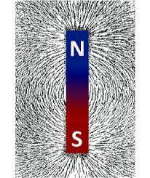

**Figure 4.3**

**Permanent Magnet**

Ferromagnetic materials can be divided into magnetically soft materials like [annealed](https://en.wikipedia.org/wiki/Annealing_(metallurgy)) [iron,](https://en.wikipedia.org/wiki/Iron) which can be magnetized but do not tend to stay magnetized, and magnetically hard materials, which do. Permanent magnets are made from hard ferromagnetic materials such as [alnico](https://en.wikipedia.org/wiki/Alnico) and [ferrite](https://en.wikipedia.org/wiki/Ferrite_(magnet)) that are subjected to special processing in a strong magnetic field during manufacture to align their

15

internal [microcrystalline structure,](https://en.wikipedia.org/wiki/Crystallite) making them very hard to demagnetize. To demagnetize a saturated magnet, a certain magnetic field must be applied, and this threshold depends on [coercivity](https://en.wikipedia.org/wiki/Coercivity) of the respective material. Hard materials have high coercivity, whereas soft materials have low coercivity. The overall strength of a

magnet is measured by its [magnetic moment](https://en.wikipedia.org/wiki/Magnetic_moment) or, alternatively, the total [magnetic](https://en.wikipedia.org/wiki/Magnetic_flux) [flux](https://en.wikipedia.org/wiki/Magnetic_flux) it produces. The local strength of magnetism in a material is measured by its [magnetization.](https://en.wikipedia.org/wiki/Magnetization)

16

**CHAPTER 5**

**WORK PIECE MATERIAL**

**5.1 Aluminium 6061**

Al6061 is a precipitation-hardened aluminium alloy, containing magnesium and silicon as its major alloying elements. It has good mechanical properties, exhibit good weldability, and is very commonly extruded. It is one of the most common alloys of aluminium for general purpose use.

In this project, the study on machining of Al6061 using shear stresses develops on MR Fluid is conducted. This material has wide range of applications in automotive and many other industries. The surface finish characteristics has been presented by surface roughness tester at microns level.

Many studies and research are still going on to find out the best compatible and cost effective finishing process for especially Al6061 material.

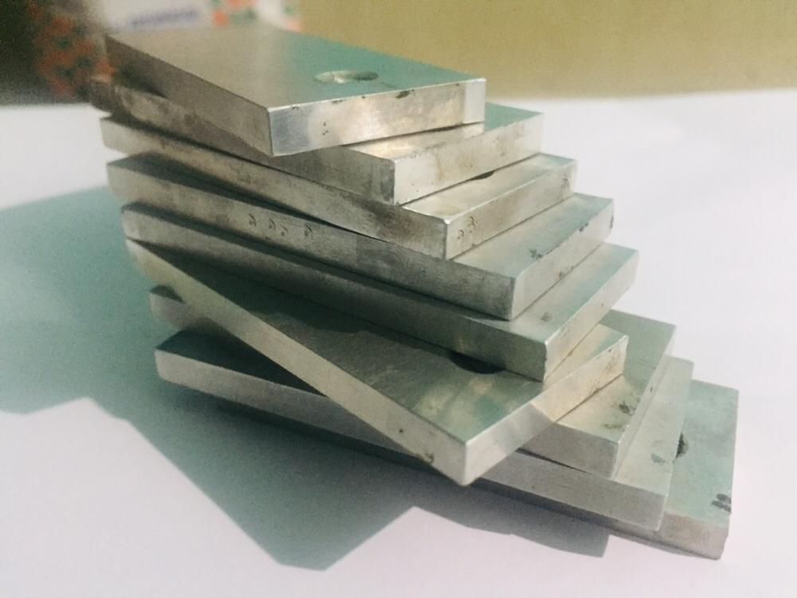

**Figure 5.1**

**Aluminium 6061 Plate**

17

The main elements are Aluminium sheet 6061 is Mg and Si with medium strength, good corrosion resistance, weldability. Alloy 6061 can be painted on the enamel and anodize oxidation colouring used as building decoration materials.

Aluminum sheet 6061 are widely used in all kinds of industrial structures which have certain strength and high antimicrobial resistance, such as manufacturing truck, take style buildings, ships, trains, furniture, machinery parts, precision machining etc.

Aluminum sheet 6061 has some differences between T6 and T651.In general, the internal stress of T6 is big and when alloy 6061 is processing, it will be out of shape. For alloy 6061, the most suitable processing condition should be T651, it is stretched based on T6 to eliminate the internal stress.

18

# CHAPTER-6 FABRICATION

Al the materials & components for our project are bought from the respective markets Mild steel L-angles, sheet metals, bearings, D.C motor, cast iron spur gear, mild steel shafts.

L-angle is cut into required number of pieces as per the dimension and welded together the weld mess metal is welded over it to form the base of the Experimental Setup.

D.C motor is fixed with the shaft of the Experimental Setup by using the bolts and nuts. Spur gear is mounted on the output shafts of the D.C motor & they are coupled with the shaft that is mounted on the shafts.

19

**CHAPTER 7**

**PRE-FINISH OF AL 6061 PLATE**

An Al 6061 plate of thickness 5mm was taken and it is converted as per required dimensions for the project. In the project, work piece is dimensioned as per suitable for the beaker diameter and the MR Fluid quantity.

The plate was taken into cutting action for the dimension of 60×25×5 mm. For the dimension, nine work piece was prepared for the different compositions of MR Fluid in the project. Then these work pieces were filed at all the surface of the work piece to remove the chips and irregularities in the work piece.

The work pieces are slightly grooved at both the surface of one top end to firmly fit in between the teeth of the tool. Initial surface roughness reading is taken before the machining by surface roughness tester.

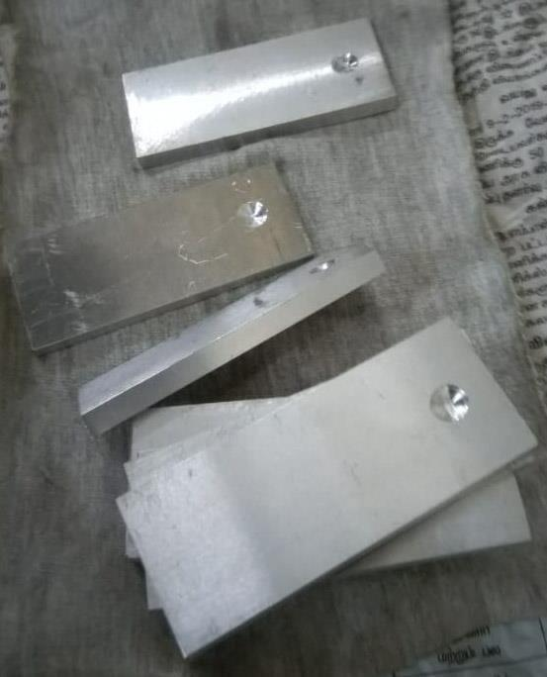

**Figure 7.1**

**Work pieces before Machining**

20

**CHAPTER 8**

**PREPARATION OF MR FLUID**

The project includes preparation of MR Fluid using different carrier fluids and additives and study effect of particle size, type and number of additives and viscosity on stability of fluid. The carrier fluid used in the project is lithium Grease. Carbonyl iron powder of size 20µm has been used. To get a better material removal, Silicon Carbide of size 30 µm is used as abrasive particles. Finally, these materials are introduced into De Ionised water at required Compositions. A brief explanation of the preparation of the MR Fluid is noted below.

The detailed steps can be described as follows.

* 1000ml transparent measurement beaker was taken, initially 500ml of De-Ionized water is poured in the beaker.
* Carbonyl iron powder (20µm) as a magnetite medium at composition of 400gms is added into the DI water and tends to stir for about 15mins.
* Lithium Grease which acts as a carrier medium as well thickening agent at a required quantity is added with Carbonyl iron powder and stirred until it obtains perfect mixture. Perfect mixture can be determined by observing the sedimentation of Carbonyl iron powder.
* Silicon Carbide (25µm) as an abrasive particle at a composition of 100gms is added into the mixture and again stirred well manually.
* Finally, the mixture is stirred in a stirring machine setup for 1hour to ensure magnetic particles are distributed evenly and reduce sedimentation.
* Hence, the particles are evenly distributed in the mixture of liquid which is called as MR Fluid.

21

**CHAPTER 9**

**DESIGN OF WORK PIECE HOLDER**

The design of new tool to hold the work piece as per the requirement was designed and produced. The purpose of the tool is to hold the work piece as well to give stirring action for MR Fluid. The tool is designed such that one end of a tool is cylindrical and tapered which is fixed into the collet of the machine. The other end is designed like forks in which two teeth are attached with adjustable align screw.

Initially a rod of 20mm is taken, the one side of the rod is turned for a radius of 12mm, as it should fix through the Setup . The other side of the rod is cut into fork like shape to hold the work piece. The align screw of 5mm is taken. The align key is used tighten and loosen the fixation work piece.

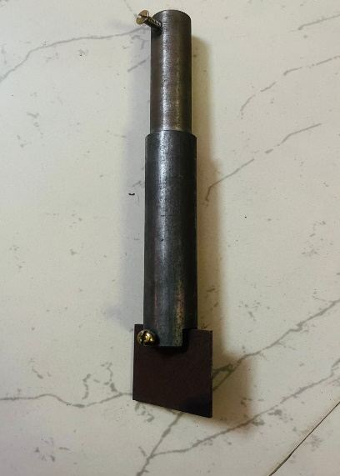

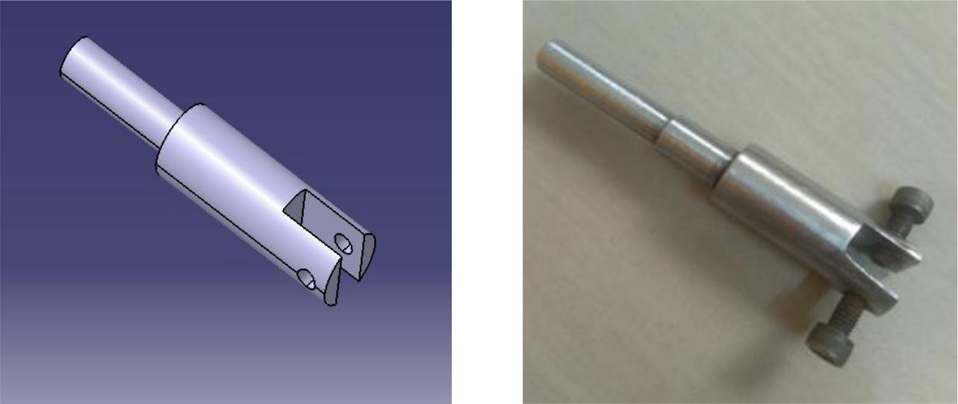

**Figure 9.1 Figure 9.2**

**3D Drawing of Work Holder After Fabricated**

**22**

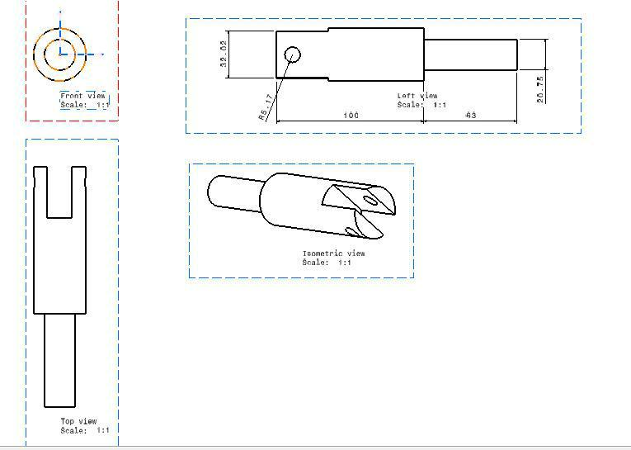

**Figure 9.3**

**Detailed View of a Tool**

**23**

**CHAPTER 10**

**EXPERIMENTAL METHOD**

**10.1 Preparation of Samples:**

Our project experimental method was carried out by using three different samples by varying the amount of silicon carbide. Since silicon carbide acts as a abrasive substance helps to remove material from the work piece to provide precise surface finish. For all three samples iron carbide of 45%, Distilled Water of 50%, grease of 10% with their total net weight respectively remains same. But according to silicon carbide the quantity varies with three different samples of 5%, 10%, 20% of their net weight.

The technical observation on increase in SiC, is directly proportional to gradual decrease in surface roughness value (RA). Since the amount of sic plays a vital role in improving surface finish. Through this experimental method we observed a great amount of good surface finish on aluminum between the range of 0.1 MICRONS (MIN) to 0.6 MICRONS (MAX).

**Table 10.1 Composition of SiC**

|  |  |  |  |  |
| --- | --- | --- | --- | --- |
| **INGREDIENTS** | **IRON** | **SILICON** | **DE-** | **GREASE** |
|  | **OXIDE** | **CARBIDE** | **IONISED** | **(%)** |
| **NO OF SAMPLES** | **POWDER** | **(%)** | **WATER** |  |
|  | **(%)** |  | **(%)** |  |
| SAMPLE 1 | 45 | 10 | 50 | 10 |
|  |  |  |  |  |
| SAMPLE 2 | 45 | 15 | 50 | 10 |
|  |  |  |  |  |
| SAMPLE 3 | 45 | 20 | 50 | 10 |
|  |  |  |  |  |

24

**10.2 Available Speed**

The machining parameters are also depending on speed of the work piece rotation. In this project three different speeds are undertaken to drive the work piece. This is because increasing the speed for a constant work piece under different composition which apparently observe changes in increase in surface finish.

**Table 10.2 Different speeds**

|  |  |  |  |
| --- | --- | --- | --- |
|  | **N1** | **N2** | **N3** |
| **SPEEDS** |  |  |  |
|  |  |  |
| **(RPM)** | 600 | 1100 | 1750 |
|  |
|  |  |  |  |



**10.3 Selection of Time**

As we know time plays a major role in everything, like wise we had also set up a time limit in accordance to ensure the surface finish should increase gradually. Therefore, the time that we applied for machining is directly proportional to increase in surface finish. The time limit varies with the intervals of 30 Mins for 3 periodic cycle that equals 90mins for each workpiece under one speed of rotation.

It has also observed that after 90 mins ie, after three complete cycle the results shows increase in surface roughness. Practically it proves restriction of speed for a particular material would be necessary to achieve good surface finish.

25

**CHAPTER 11**

**EXPERIMENTAL SETUP**

**11.1 Experimental Setup**

DC motor is fixed at the shaft of the Experimental Setup. The supply of the current is given by the 12-volt main supply provided. This 12-volt dc by using power supply. This machine combines the principles of reciprocating machine the rotary motion converted to reciprocating by using screw rod shaft mechanism.

DC motor is coupled to main shaft by spur gear mechanism which is made up of cast iron. This will used to increase the torque of the machine.

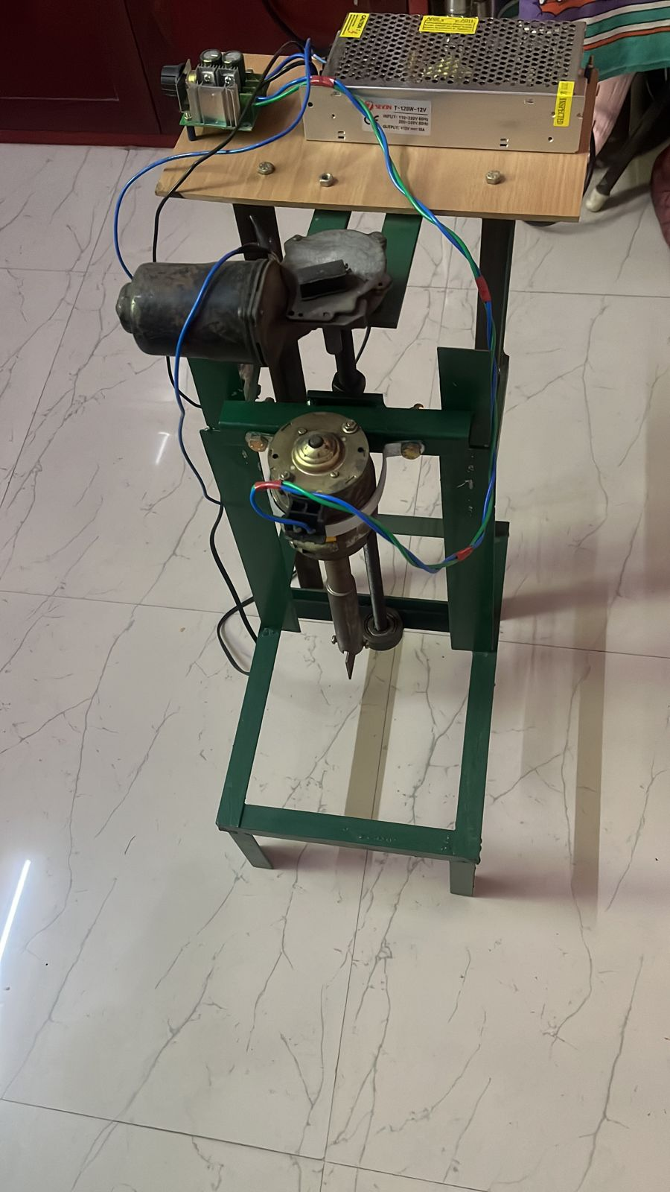 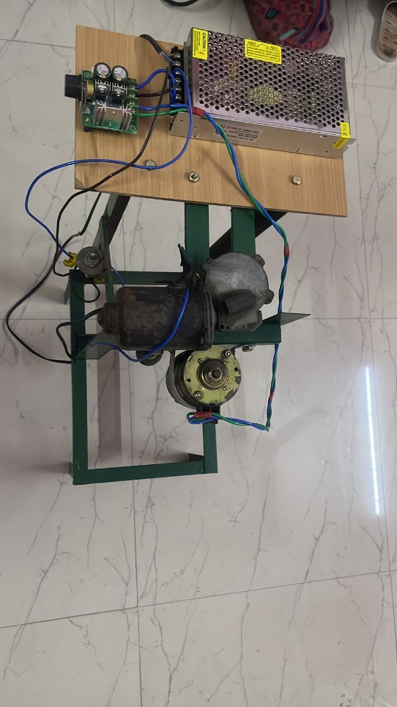

26

**11.2 Surface Roughness Tester**

Surface roughness often shortened to roughness, is a component of surface texture. It is quantified by the deviations in the direction of the normal vector of a real surface from its ideal form. If these deviations are large, the surface is rough; if they are small, the surface is smooth. In surface meteorology, roughness is typically considered to be the high-frequency, short-wavelength component of a measured surface. However, in practice it is often necessary to know both the amplitude and frequency to ensure that a surface is fit for a purpose.

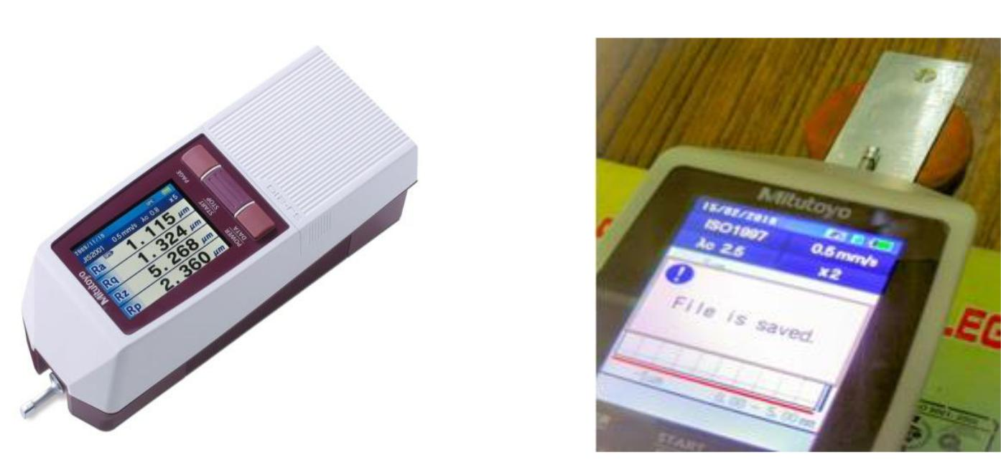

**Figure 11.2**

**Surface Roughness Tester**

Roughness can be measured by manual comparison against a "surface roughness comparator" (a sample of known surface roughness), but more generally a surface profile measurement is made with a profilometer. These can be of the contact variety (typically a diamond stylus) or optical (e.g., a white light interferometer or laser scanning confocal microscope).

A Surface Roughness Tester is used to determine the surface texture or surface roughness of a material quickly and accurately. A roughness tester shows the measured roughness depth (Rz) as well as the mean roughness value (Ra) in micrometers or microns (µm).

27

**11.3 Procedure for Measuring Surface Roughness:**

A diamond stylus is moved vertically in contact with a sample and then moved laterally across the sample for a specified distance and specified contact force. A profilometer can measure small surface variations in vertical stylus displacement as a function of position. A typical profilometer can measure small vertical features ranging in height from 10 nanometers to 1 millimeter. The height position of the diamond stylus generates an analog signal which is converted into a digital signal, stored, analyzed, and displayed. The radius of diamond stylus ranges from 20 nanometers to 50 μm, and the horizontal resolution is controlled by the scan speed and data signal sampling rate. The stylus tracking force can range from less than 1 to

1. milligrams.
   * **Acceptance**: Most of the world's surface finish standards are written forcontact profilometers. To follow the prescribed methodology, this type of Profilometer is often required.
   * **Surface Independence**: Contacting the surface is often an advantage indirty environments where non-contact methods can end up measuring surface contaminants instead of the surface itself. Because the stylus is in contact with the surface, this method is not sensitive to surface reflectance or color.
   * **Resolution:** The stylus tip radius can be as small as 20 nanometres,significantly better than white-light optical profiling. Vertical resolution is typically sub-nanometer as well.
   * **Direct Technique**: No modeling required.

28

**11.4 Parameters in Surface Roughness:**

**11.4.1 Mean Roughness (Ra):**

Ra is also known as Arithmetic Average (AA) or Center Line Average (CLA). It is the average roughness in the area between the roughness profile and its mean line. Graphically, Ra is the area between the roughness profile and its centerline divided by the evaluation length. The evaluation length is normally five sample lengths where each sample length is equal to one cutoff length.

**11.4.2 Root Mean Square deviation (Rq):**

The Root Mean Square deviation indicates the root mean square along the sampling length. It is the average of the profile heights over the evaluation length.

**11.4.3 Average Maximum Height of the Profile (Rz):**

This parameter is the average of the successive values of Rti calculated over the evaluation length. It is the same as Rz when there are five sampling lengths within the evaluation length.

**11.4.4 Unit Conversion of Surface Roughness**

*Rz = Ra × 7.2*

*RMS = Ra x 1.1*

*RQ = RMS*

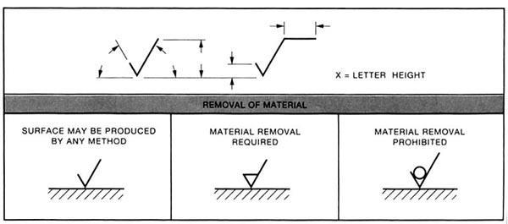

**Figure 11.4**

**ISO surface finish symbol**

29

**CHAPTER 12**

**RESULTS AND DISCUSSION**

As per the research on obtaining surface finish with help of magneto rheological fluid at different composition and at different speed it seen that there is gradual change at every individual parameter changes.

Work piece which had initial surface roughness of about 0.758µm is made to run at 600rpm in a 5% composition and for every 30mins the roughness of the work piece is tested. It is clear the surface roughness gets reduced and shows a positive result. The obtained results were, after 30mins the result was 0.651 µm and after 60mins the result was 0.528 µm and after 90mins the result was 0.486 µm. the range at which the surface roughness starts increasing is known as critical range. Probably most of the work piece showed good results till 90mins beyond which the results had a negative impact.

The graph of surface roughness shows a gradual drop till 90mins and beyond which it starts increasing. At same rpm running a work piece in a 10% composition which had initial surface roughness of about 0.416µm the results obtained at everyone 30mins where, after running for 30mins 0.25 µm and after 60mins 0.077 µm and finally after 90mins 0.076 µm beyond which the value increases.

It is clear upon drawing a graph between time and surface roughness, the surface roughness value drops gradually till 90mins and beyond which it starts increasing. In the same manner at same rpm and 15% composition the results obtained, the initial value was 0.401 µm and after 30mins the value was 0.366 µm and after running for 60mins the value was 0.183 and after running for 90mins the value was 0.081 µm and even in this case as like other the value started increasing beyond 90mins showing negative impact on the result.

30

**12.1 TABULATION**

**Table 12.1 Surface Roughness (Ra) Values at 600 rpm**

|  |  |  |  |  |
| --- | --- | --- | --- | --- |
| 600 RPM | | | | |
|
| TIME (min)  COMPOSITION | INITIAL (RA) | 30 | 60 | 90 |
|
| 5% | 0.728 | 0.651 | 0.524 | 0.486 |
|
| 10% | 0.416 | 0.25 | 0.077 | 0.076 |
|
| 15% | 0.401 | 0.366 | 0.183 | 0.081 |
|

**Table 12.2 Surface Roughness (Ra) Values at 1100 rpm**

|  |  |  |  |  |
| --- | --- | --- | --- | --- |
| 1100 RPM | | | | |
| TIME (min)  COMPOSITION | INITIAL (RA) | 30 | 60 | 90 |
|
|
| 5% | 0.387 | 0.251 | 0.195 | 0.16 |
|
| 10% | 0.333 | 0.248 | 0.193 | 0.185 |
|
| 15% | 0.389 | 0.252 | 0.238 | 0.182 |
|

31

**Table 12.3 Surface Roughness (Ra) Values at 1750 rpm**

|  |  |  |  |  |
| --- | --- | --- | --- | --- |
| 1750 RPM | | | | |
|
| TIME (min)  COMPOSITION | INITIAL (RA) | 30 | 60 | 90 |
|
|
| 5% | 0.21 | 0.153 | 0.112 | 0.109 |
|
| 10% | 0.431 | 0.326 | 0.205 | 0.179 |
|
| 15% | 0.366 | 0.187 | 0.155 | 0.129 |
|

**11.2 PERCENTAGE DECREASE IN SURFACE ROUGHNESS**

|  |  |  |  |
| --- | --- | --- | --- |
| **PERCENTAGE DECREASE IN RA VALUES (%) FROM INITIAL** | | | |
| TIME (Mins)  SIC | 30 | 60 | 90 |
|
| SAMPLE 1 (5%) | 10.57 | 28.02 | 33.24 |
| SAMPLE 2 (10%) | 39.9 | 81.49 | 81.73 |
| SAMPLE 3 (15%) | 8.72 | 54.36 | 79.8 |

**Table 12.4 Percentage Decrease**

32

**Table 12.5 Surface Roughness (Ra) at 600 rpm**

**Composition – 5% SiC**

|  |  |  |  |
| --- | --- | --- | --- |
| **Initial Ra** | **30 Mins** | **60 Mins** | **90Mins** |
|  |  |  |  |
|  |  |  |  |
|  |  |  |  |
|  |  |  |  |

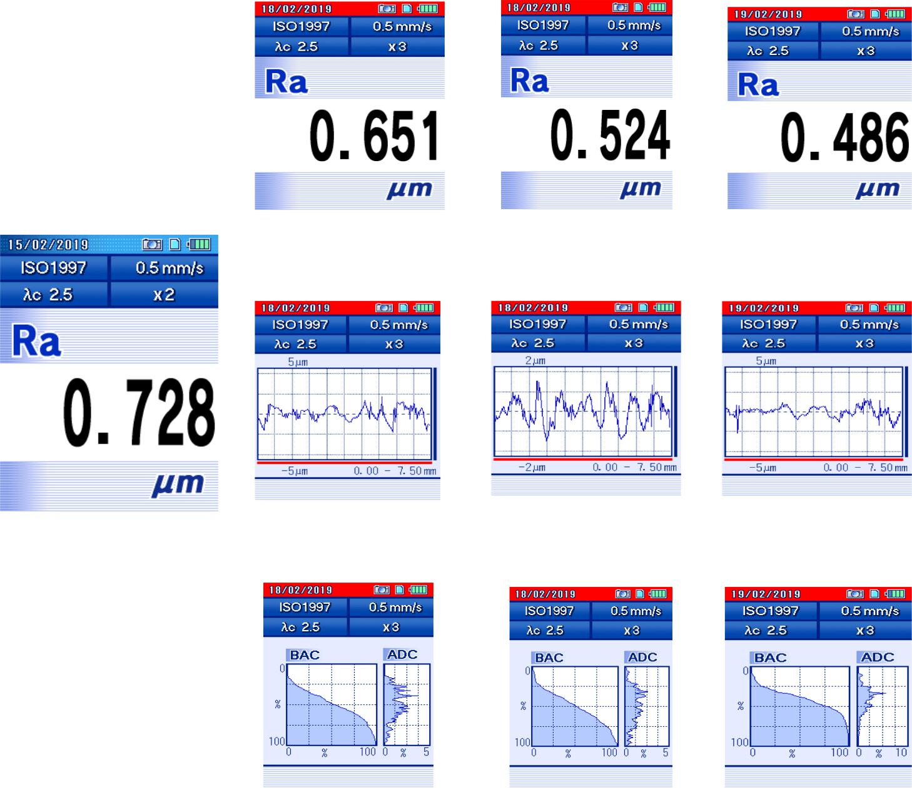

33

**Table 12.6 Surface Roughness (Ra) at 600 rpm**

**Composition – 10% SiC**

|  |  |  |  |
| --- | --- | --- | --- |
| **Initial (Ra)** | **30 Mins** | **60Mins** | **90Mins** |
|  |  |  |  |
|  |  |  |  |
|  |  |  |  |
|  |  |  |  |

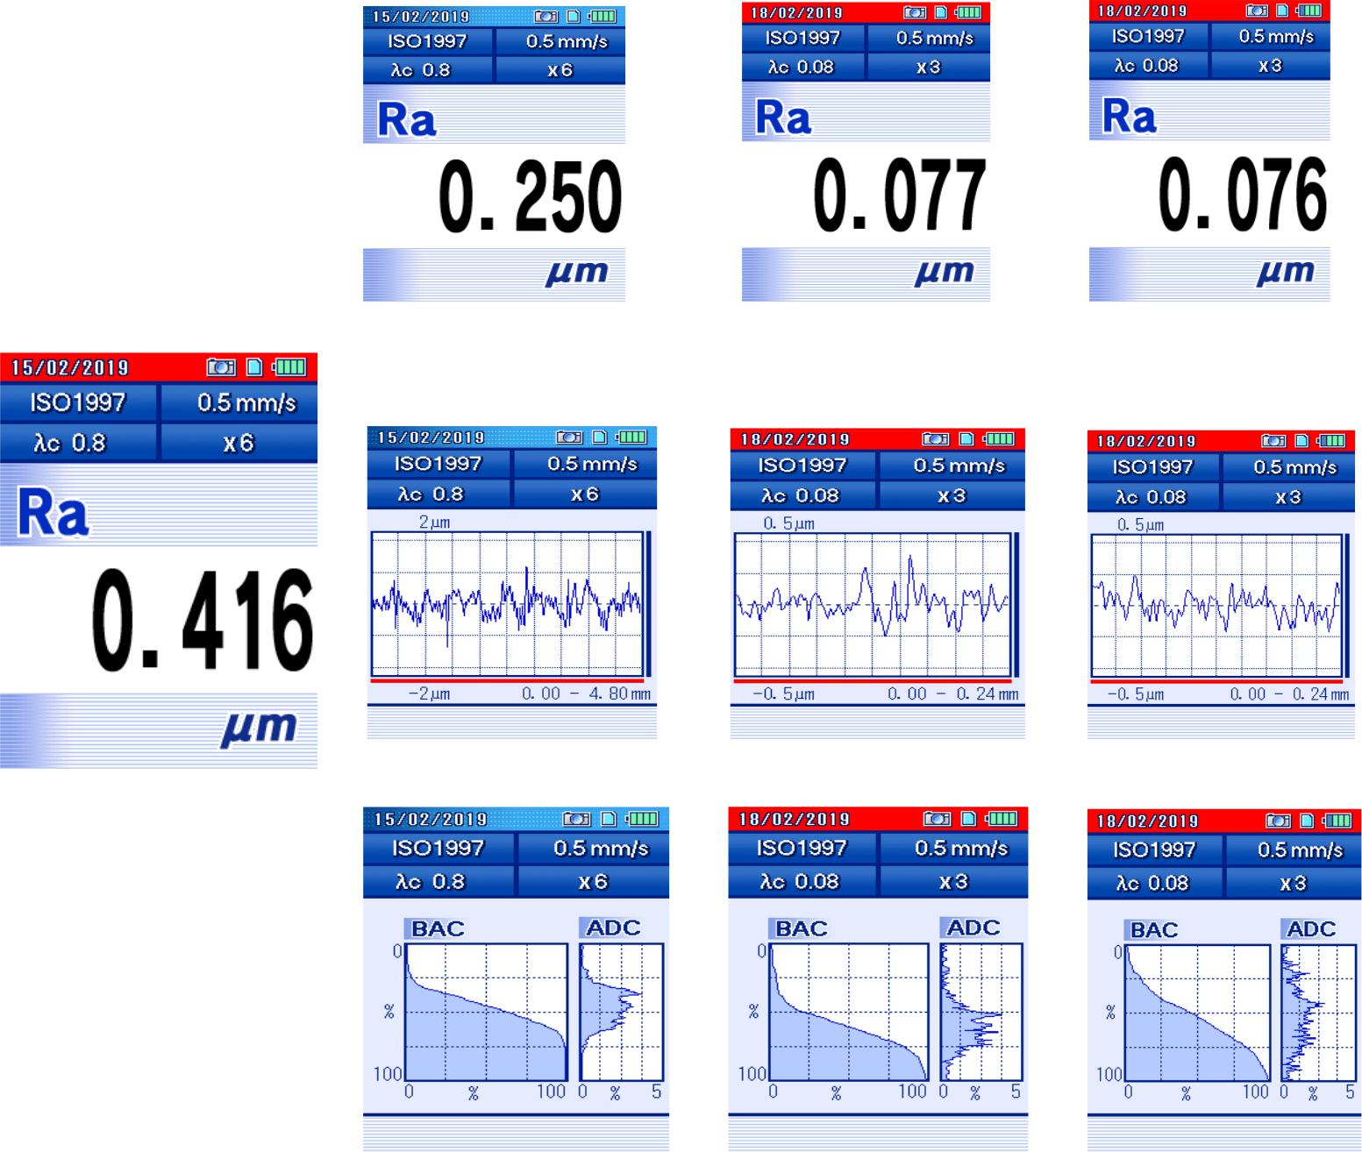

34

**Table 12.7 Surface Roughness (Ra) at 600 rpm**

**Composition – 15% SiC**

|  |  |  |  |
| --- | --- | --- | --- |
| **Initial (Ra)** | **30 Mins** | **60Mins** | **90Mins** |
|  |  |  |  |
|  |  |  |  |
|  |  |  |  |
|  |  |  |  |

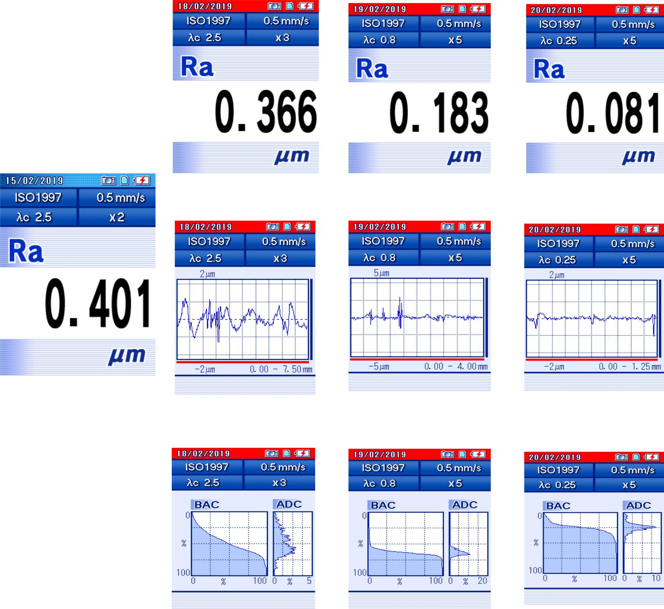

**35**

**CHAPTER 13**

**COST ESTIMATION**

**Table 13.1 Cost Estimation**

|  |  |  |  |
| --- | --- | --- | --- |
| **SL.NO** | **MATERIALS** | **QUANTITY** | **COST (INR)** |
|  |  |  |  |
| 1 | Measurement Beaker | 1 | 100 |
|  |  |  |  |
| 2 | Carbonyl iron powder | 2000 gms | 3600 |
|  |  |  |  |
| 3 | Aluminium Raw Material | 500 gms | 830 |
|  |  |  |  |
| 4 | Aluminium Pre-Machining | - | 400 |
|  |  |  |  |
| 5 | Silicon Carbide Powder | 500 gms | 450 |
|  |  |  |  |
| 6 | Lithium Grease | 250 gms | 60 |
|  |  |  |  |
| 7 | Permanent Magnet | 4 | 100 |
|  |  |  |  |
| 8 | Deionized Water | 5 ltrs | 500 |
|  |  |  |  |
| 9 | Miscellaneous | - | 200 |
|  |  |  |  |
|  |  | **TOTAL** | **6240** |
|  |  |  |  |

36

**CHAPTER 14**

**SCOPE OF FUTURE PROJECT**

The development of Nanotechnology is becoming a viral part in wide range of applications in the industries. In those applications, one of the most evolving fields is Nano finishing, in which the target is to obtain the surface finish of a material better than it achieves in existing Super finishing process and techniques.

An approach of technology is given by using the science of chemistry which is called as Magnetorheological Technology. Which is introduced into the Nano finishing Process to the manufacturing sectors. The approach can be used in automobile industries, space, and the places where the requirement of additional finishing is to be done.

Moreover, in MR fluid assisted machining process the surface finish can obtained by considering various parameters such as magnetic flux which has direct effect on viscosity. The magnetic flux value can be controlled with help of electromagnet, and which has an effect on finish.

The project will be taken to the next level of research to achieve the ease of acquire all the material to adopt this technique.

37

**CHAPTER 15**

**CONCLUSION**

By considering the objectives and by reviewing the literature, various executions were studied and implemented in the project. The Magnetorheological Fluid was used as source of micro finishing of an Aluminium 6061 plate.

It is observed that the surface finish of a material depends upon the magnetic field strength and as well as the perfect composition of additives involved in the MR Fluid. It is concluded as follows.

* Increasing the magnetic field increases viscos elasticity of the fluid up to to the certain limit and thereafter shear stress involves in the material removal process.
* The results and tabulation show that the variation in the surface finish according to the addition of Silicon Carbide.
* The variation in rotational speed and consecutive increase of time of rotations for the respective speeds gives a decrement in the roughness value gradually. This gradual decrement is maintained for the particular limit of time and hence the project was taken to the extreme time limit.

38

**CHAPTER 16**

**REFERENCES**

* Optimization of Machining Parameters during CNC turning of Aluminium 6061 with CNMG EN-TM(H20TI) insert using Response Surface Methodology.
* (Jasvir Singh, Harvinder Singh, Gagandeep Singh Dhindsa)
* Marzena SUTOWSKA1, Pawel SUTOWSKI2 , 1,2Koszalin University of Technology, Faculty of Mechanical Engineering, Unconventional Hydro Jetting Technology Center, Poland. (Contemporary Applications of magneto Rheological Fluids for Finishing).
* Mukul Kataria1 , S.K. Mangal2 , 1Research Scholar, 2Associate Professor, Mechanical Engineering Department, PEC University of Technology, Chandigarh. (Effect of Magnetic Field in Magneto Rheological Fluid Finishing Process).
* Ganapathy Srinivasan R1 , Shanmugan S2 and Palani S3 .123 Veltech Multi Tech. (Applications of Magneto Rheological Fluid in Machining Process).
* V.K. Jain*, Indian Institute of Technology, Mechanical Engineering, Kanpur 208016, Uttar Pradesh, India. (Magnetic field assisted abrasive based micro-/nano-finishing).
* Ajay Sidpara, V.K.Jain*, Mechanical Engineering Department, Indian Institute of technology – Kanpur, India. (Experimental investigations into forces during magneto rheological fluid-based finishing process).
* K.Saraswathamma* , Mechanical Engineering Department, Osmania University, Hyderabad, India. (Magneto Rheological Finishing)

39